**Microspectra Software Technology Pvt. Ltd**

**Name of student:** Apeksha Birbalsing Rajput

**Branch:** Computer Science and Engineering

**College Name:** Government Polytechnic Khamgaon

1. **To study Artificial Intelligence its needs & Applications in various domain.**
   1. **What is an Artificial Intelligence?**

Artificial Intelligence is an simulation of human intelligence in machines that are programmed to think like humans and mimic their actions. The term may also be applied to any machine that exhibits traits associated with a human mind such as learning and problem-solving.

The ideal characteristic of artificial intelligence is its ability to rationalize and take actions that have the best chance of achieving a specific goal.

**1.2 Why do we Need of an Artificial Intelligence**

We need Artificial Intelligence (AI) because the work that we need to do is increasing day-to-day. So it’s a good idea to automate the routine work. This saves the manpower of the organization and also increases the productivity. Additionally, through this Artificial Intelligence, the company can also get the skilled the persons for the development of the company. Moreover the companies today think that they want to mechanize all the regular and routine work. And they think they can automate those regular works through the simple program Because, with the development of data science,  automation becomes more common. The application of this AI is majorly seen at website chat portal. You people when you come to the websites probably seen the welcome message. Then after actual conversation usually starts.

There are the four categories of an artificial intelligence are as follows:

**1. Reactive machines :**

A good example of this Reactive machines is Deep blue. And this is usually applied in Chess Board. This can identify the pieces of the chess board and make predictions. But the drawback is that it does not have memory. It means, it cannot use the past experiences to predict the future. So it just uses the current situation and just moves the pawn. It is intended for the application of a small situation. The situation could be handled within a moment itself.

1. **Theory of mind :**

This type of AI refers to the understanding of other behaviors and do the work according to It includes the feeling.  the intention, moves of the other person. In general, this kind of AI still does not exist. And today most of the scientists ware working hard to get it practically.

1. **Limited Memory :**

This type of AI is applied where there is a need for memory. Some machines work on the basis of the past experience. It means they the information of the same thing that happened in the past and does the current work accordingly. This type of AI majority used in the areas of self-driving cars. It uses its memory to act in situations like traffic collisions.

1. **Self-awareness:**

Like the above type, this type of  Artificial Intelligence systems, need to bring practically. They think that these systems should have a self-awareness and must have a capability to understand the feeling of others.

**1.3 Application of an Artificial Intelligence**

1. **Healthcare:**

Artificial intelligence in healthcare is often used for classification, whether to automate initial evaluation of a CT scan or EKG or to identify high-risk patients for population health. The breadth of applications is rapidly increasing. As an example, AI is being applied to the high-cost problem of dosage issues—where findings suggested that AI could save $16 billion.

1. **Automotive:**

Advancements in AI have contributed to the growth of the automotive industry through the creation and evolution of self-driving vehicles. As of 2016, there are over 30 companies utilizing AI into the creation of [self-driving cars](https://en.m.wikipedia.org/wiki/Self-driving_car). A few companies involved with AI include [Tesla](https://en.m.wikipedia.org/wiki/Tesla_Motors), [Google](https://en.m.wikipedia.org/wiki/Google), and [Apple](https://en.m.wikipedia.org/wiki/Apple_Inc.).

Many components contribute to the functioning of self-driving cars. These vehicles incorporate systems such as braking, lane changing, collision prevention, navigation and mapping. Together, these systems, as well as high-performance computers, are integrated into one complex vehicle.

1. **Finance and Economics:**

[Financial institutions](https://en.m.wikipedia.org/wiki/Financial_institution) have long used [artificial neural network](https://en.m.wikipedia.org/wiki/Artificial_neural_network) systems to detect charges or claims outside of the norm, flagging these for human investigation. The use of AI in [banking](https://en.m.wikipedia.org/wiki/Banking) can be traced back to 1987 when [Security Pacific National Bank](https://en.m.wikipedia.org/wiki/Security_Pacific_National_Bank) in the US set-up a Fraud Prevention Task force to counter the unauthorized use of debit cards. Programs like Kasisto and Money stream are using AI in financial services.

Banks use artificial intelligence systems today to organize operations, maintain book-keeping, invest in stocks, and manage properties. AI can react to changes overnight or when business is not taking place. In August 2001, robots beat humans in a simulated [financial trading](https://en.m.wikipedia.org/wiki/Stock_trader) competition. AI has also reduced fraud and financial crimes by [monitoring](https://en.m.wikipedia.org/wiki/Statistical_software) [behavioral patterns](https://en.m.wikipedia.org/wiki/Behavioral_pattern" \o "Behavioral pattern) of users for any abnormal changes or anomalies.

AI is increasingly being used by [corporations](https://en.m.wikipedia.org/wiki/Corporate_finance). [Jack Ma](https://en.m.wikipedia.org/wiki/Jack_Ma) has controversially predicted that AI [CEO](https://en.m.wikipedia.org/wiki/CEO)'s are 30 years away.

1. **Cybersecurity:**

The [cybersecurity](https://en.m.wikipedia.org/wiki/Cybersecurity) arena faces significant challenges in the form of large-scale hacking attacks of different types that harm organizations of all kinds and create billions of dollars in business damage. Artificial intelligence and Natural Language Processing (NLP) has begun to be used by security companies.

1. **Government:**

Artificial intelligence in government consists of applications and regulation. Artificial intelligence paired with [facial recognition systems](https://en.m.wikipedia.org/wiki/Facial_recognition_system) may be used for [mass surveillance](https://en.m.wikipedia.org/wiki/Mass_surveillance). This is already the case in some parts of China. Artificial intelligence has also competed in the Tama City [mayoral elections](https://en.m.wikipedia.org/wiki/AI_mayor) in 2018.

This system will involve use of cameras to ascertain traffic density and accordingly calculate the time needed to clear the traffic volume which will determine the signal duration for vehicular traffic across streets.

1. **Law related professions:**

Artificial intelligence (AI) is becoming a mainstay component of law-related professions. In some circumstances, this analytics-crunching technology is using algorithms and machine learning to do work that was previously done by entry-level lawyers.

In [Electronic Discovery (eDiscovery)](https://en.m.wikipedia.org/wiki/Electronic_discovery), the industry has been focused on machine learning which is a subset of AI. To add to the soup of applications, Natural Language Processing (NLP) and Automated Speech Recognition (ASR) are also in vogue in the industry.

1. **Video games:**

In video games, artificial intelligence is routinely used to generate dynamic purposeful behavior in [non-player characters](https://en.m.wikipedia.org/wiki/Non-player_character) (NPCs). In addition, well-understood AI techniques are routinely used for [pathfinding](https://en.m.wikipedia.org/wiki/Pathfinding). Some researchers consider NPC AI in games to be a "solved problem" for most production tasks.

1. **Military:**

The United States and other nations are developing AI applications for a range of military functions.[[324]](https://en.m.wikipedia.org/wiki/Artificial_intelligence#cite_note-:2-335) The main military applications of Artificial Intelligence and Machine Learning are to enhance C2, Communications, Sensors, Integration and Interoperability. AI research is underway in the fields of intelligence collection and analysis, logistics, cyber operations, information operations, command and control, and in a variety of semiautonomous and autonomous vehicles.

1. **Hospitality:**

In the hospitality industry, Artificial Intelligence based solutions are used to reduce staff load and increase efficiency. by cutting repetitive tasks frequency, trends analysis, guest interaction, and customer needs prediction. Hotel services backed by Artificial Intelligence are represented in the form of a chatbot, application, virtual voice assistant and service robots.

1. **Audit:**

Artificial intelligence makes continuous audit possible. AI tools could analyze many sets of different information immediately. The potential benefit would be the overall audit risk will be reduced, the level of assurance will be increased and the time duration of audit will be reduced.

1. **Advertising:**

It is possible to use AI to predict or generalize the behavior of customers from their [digital footprints](https://en.m.wikipedia.org/wiki/Digital_footprints) in order to target them with personalized promotions or build customer personas automatically. A documented case reports that online gambling companies were using AI to improve customer targeting.

1. **Art:**

Artificial Intelligence has inspired numerous creative applications including its usage to produce visual art. The exhibition "Thinking Machines: Art and Design in the Computer Age, 1959–1989" at MOMA provides a good overview of the historical applications of AI for art, architecture, and design.

**2.To study 3D Printing Technology it’s needs and Application in various domain.**

* 1. **3D Printing Technology:**

3D printing, or additive manufacturing, is the construction of a three-dimensional object from a [CAD](https://en.wikipedia.org/wiki/Computer-aided_design) model or a digital [3D model.](https://en.wikipedia.org/wiki/3D_modeling) The term "3D printing" can refer to a variety of processes in which material is deposited, joined or solidified under [computer](https://en.wikipedia.org/wiki/Computer_Numerical_Control) [control](https://en.wikipedia.org/wiki/Computer_Numerical_Control) to create a [three-dimensional](https://en.wikipedia.org/wiki/Three-dimensional_space) object, with material being added together (such as liquid molecules or powder grains being fused together), typically layer by layer.

In the 1980s, 3D printing techniques were considered suitable only for the production of functional or aesthetic prototypes, and a more appropriate term for it at the time was [rapid prototyping.](https://en.wikipedia.org/wiki/Rapid_prototyping) As of 2019, the precision, repeatability, and material range of 3D printing has increased to the point that some 3D printing processes are considered viable as an industrial-production technology, whereby the term additive manufacturing can be used synonymously with 3D printing. One of the key advantages of 3D printing is the ability to produce very complex shapes or geometries that would be otherwise impossible to construct by hand, including hollow parts or parts with internal truss structures to reduce weight. [Fused deposition modeling](https://en.wikipedia.org/wiki/Fused_filament_fabrication#Fused_deposition_modeling), or FDM, is the most common 3D printing process in use as of 2018.

There are many different branded [3D printing processes](https://en.wikipedia.org/wiki/3D_printing_processes) that can be grouped into seven categories

* [Vat photopolymerization](https://en.wikipedia.org/wiki/3D_printing_processes#Photopolymerization)
* Material jetting
* [Binder jetting](https://en.wikipedia.org/wiki/3D_printing_processes#Binder_jetting)
* Powder bed fusion
* [Material extrusion](https://en.wikipedia.org/wiki/3D_printing_processes#Extrusion_deposition)
* Directed energy deposition
* [Sheet lamination](https://en.wikipedia.org/wiki/3D_printing_processes#Lamination)

## *Fig.3D printing technology*

## **Pros and Cons of 3D Printing**

* Freedom of Design. 3D printing boasts the ability to produce complex geometry that machining and injection molding may struggle with or may simply not be able to make.
* Rapid Prototyping.
* Print on Demand.
* Lighter, Stronger Parts.
* Waste Reduction.
* Speed.
* Cost-Effective.
* Accessibility.
  1. **Need of an 3D printing technology**

3D printing is inexpensive prosthetics, creating spare parts, rapid prototyping, creating personalized items and manufacturing with minimum waste. The technology is useful and thanks to its widespread availability as well as further development will be even more useful in the future.

* 1. **Application of an 3D printing technology**
* **Education:**

Students learn about a variety of 3D printing applications by exploring design, engineering, and architectural principles. They are able to duplicate museum items like fossils and historical artifacts to study in the classroom without the possibility of damaging delicate collections. They are able to gain a new, 3-dimensional perspective on topographic maps.

* **Prototyping and Manufacturing:**

3D printing was first developed as a means for faster [prototyping](https://www.interaction-design.org/literature/article/design-thinking-get-started-with-prototyping). With a traditional injection-molded prototype it might cost hundreds of thousands of dollars and take weeks to produce a single mold. That is highly impractical if you are trying to improve on design with each new iteration.

Traditional manufacturing is the most cost-effective at large volumes. In situations where a product is not going to be mass produced, 3D printing (aka ‘additive manufacturing’ in manufacturing circles) is ideal as it allows for the relatively inexpensive production of a product in much smaller volumes or on a case-by-case basis.

* **Medicine:**

3D printing applications in medicine are also used for producing metal orthopedic implants. Due to 3D printing’s capabilities for creating porous surfaces, these types of implants more easily integrate with the patient’s own natural bones, allowing them to grow into the implant.

* **Construction:**

3D printing applications that are used in construction include extrusion (concrete/cement, wax, foam, and polymers), powder bonding (polymer bond, reactive bond, sintering) and additive welding. 3D printing in construction has a wide array of applications in the private, commercial, industrial and public sectors.

* **Art and Jewellery:**

3D printers allow jewelry makers to experiment with designs not possible with traditional jewelry making methods. 3D printing also allows the production of individual, unique pieces of jewelry or customized pieces at a much lower cost, using 3D printing materials such as PLA (polylactic acid filament), gold or platinum.

# **To study Internet of Things its needs & Applications in various domain.**

* 1. **Internet Of Things:**

The Internet of Things is an emerging topic of technical, social, and economic significance. Consumer products, durable goods, cars and trucks, industrial and utility components, sensors, and other everyday objects are being combined with Internet connectivity and powerful data analytic capabilities that promise to transform the way we work, live, and play. Projections for the impact of IoT on the Internet and economy are impressive, with some anticipating as many as 100 billion connected IoT devices and a global economic impact of more than $11 trillion by 2025..

The “INTERNET OF THINGS(IOT)” reffers to the ever-growing network of physical objects that features an IP address for Internet Connectivity, and the feature an IP address for Internet connectivity, and the communication that occurs between these objects and other Internet enabled devices and systems.

In simple words, IOT is an ecosystem of connected physical objects that are accessible through the Internet.

## **Scope of IOT**

IOT can connect devices embedded in various systems to the internet. When devices/objects can represent themself digitally, they can be controlled from anywhere.

The connectivity then helps us capture more data from more places, ensuring more ways of increasing efficiency.

* 1. **Need of an Internet of things**

Need of an internet of things are as follows:

* **More data means better decisions**

With added sensors, these devices are able to collect a large amount of data on many different areas. A greater flow of information means that company behind the device can analyse large trends in the data to better improve the features of the device.

* **Ability to track and monitor things**

These devices would have the ability to keep an eye out on the current quality of goods at home. Knowing the state of your items will allow a homeowner to know when they need to replace an item, without them having to consistently check the quality themselves.

* **Lighten the workload with automation**

Having a device doing most the work for you means that you can save more time and cost. Imagine having your fridge order a new carton of milk to be delivered when it reaches a certain level level of expiry? Sounds good to me.

* **Increases efficiency by saving money and resources**

As well as saving time for the device owner, it can also result in cost savings. For example, if lights automatically turn themselves off the moment you leave the room, you could save a lot of money on you electricity bills.As you can see, connected devices can provide many useful implementations. The IoT system encourages machine to machine (M2M) communication resulting in increased long term efficiency for both the company and user.

* **Better quality of life**

Having your devices track and order things for you, turn light switches off for you, and help manage important tasks that you may not have the time to do yourself certainly takes away a lot of stress.

* 1. **Application of an internet of things**
* **Smart Home:** Smart Home has become the revolutionary ladder of success in the residential spaces and it is predicted Smart homes will become as common as  smartphones.
* **Wearables:** Wearables have experienced a explosive demand in markets all over the world. Companies like Google, Samsung have invested heavily in building such devices.
* **Connected cars:** The automotive digital technology has focused on optimizing vehicles internal functions. But now, this attention is growing towards enhancing the in-car experience.

A connected car is a vehicle which is able to optimize it’s own operation, maintenance as well as comfort of passengers using onboard sensors and internet connectivity.

* **Industrial Internet:** Industrial Internet is the new buzz in the industrial sector, also termed as Industrial Internet of Things. It is empowering industrial engineering with sensors, software and big data analytics to create brilliant machines.
* **Smart cities:** Smart city is another powerful application of IoT generating curiosity among world’s population. Smart surveillance, automated transportation, smarter energy management systems, water distribution, urban security and environmental monitoring all are examples of internet of things applications for smart cities.
* **Internet of things in agriculture:** With the continous increase in world’s population, demand for food supply is extremely raised. Governments are helping farmers to use advanced  techniques and research to increase food production. Smart farming is one of the fastest growing field in IoT.
* **Smart Retail:** The potential of IoT in the retail sector is enormous. IoT provides an opportunity to retailers to connect with the customers to enhance the in-store experience.
* **Energy Engagement:** The basic idea behind the smart grids is to collect data in an automated fashion and analyze the behavior or electricity consumers and suppliers for improving efficiency as well as economics of electricity use.
* **Internet of things in Healthcare:** Connected healthcare yet remains the sleeping giant of the Internet of Things applications. The concept of connected healthcare system and smart medical devices bears enormous potential not just for companies, but also for the well-being of people in general.

# **To Study Machine Learning its needs & Applications in various domain.**

## **Machine Learning**

Machine learning (ML) is the study of computer algorithms that improve automatically through experience. It is seen as a subset of [artificial intelligence.](https://en.wikipedia.org/wiki/Artificial_intelligence) Machine learning algorithms build a [mathematical model](https://en.wikipedia.org/wiki/Mathematical_model) based on sample data, known as "[training data](https://en.wikipedia.org/wiki/Training_data)", in order to make predictions or decisions without being explicitly programmed to do so. Machine learning algorithms are used in a wide variety of applications, such as [email filtering](https://en.wikipedia.org/wiki/Email_filtering) and [computer vision,](https://en.wikipedia.org/wiki/Computer_vision) where it is difficult or infeasible to develop conventional algorithms to perform the needed tasks.

Machine learning is closely related to [computational statistics](https://en.wikipedia.org/wiki/Computational_statistics), which focuses on making predictions using computers. The study of [mathematical optimization](https://en.wikipedia.org/wiki/Mathematical_optimization) delivers methods, theory and application domains to the field of machine learning. [Data](https://en.wikipedia.org/wiki/Data_mining) [mining](https://en.wikipedia.org/wiki/Data_mining) is a related field of study, focusing on [exploratory data](https://en.wikipedia.org/wiki/Exploratory_data_analysis) [analysis](https://en.wikipedia.org/wiki/Exploratory_data_analysis) through [unsupervised learning.](https://en.wikipedia.org/wiki/Unsupervised_learning) In its application across business problems, machine learning is also referred to as [predictive analytics.](https://en.wikipedia.org/wiki/Predictive_analytics)

## **Needs of Machine Learning**

Data is the lifeblood of all business. Data-driven decisions increasingly make the difference between keeping up with competition or falling further behind. Machine learning can be the key to unlocking the value of corporate and customer data and enacting decisions that keep a company ahead of the competition.

Simply put, machine learning allows the user to feed a computer algorithm an immense amount of data and have the computer analyze and make data-driven recommendations and decisions based on only the input data.

Training is the most important part of Machine Learning. Choose your features and hyper parameters carefully. Machines don't take decisions, people do. Data cleaning is the most important part of Machine Learning

Also, the goal of mechanics is to put up the production and earnings sales with less time and expenses. Machines are necessary in our life, because, all society needs then. Sometimes, the machines are dangerous and replaced labor but without these we cannot live; for this reason a mechanical engineer is very important.

## **Applications of Machine Learning**

There are many applications for machine learning, including:

* + [Agriculture](https://en.wikipedia.org/wiki/Precision_agriculture)
  + [Anatomy](https://en.wikipedia.org/wiki/Computational_anatomy)
  + [Adaptive websites](https://en.wikipedia.org/wiki/Adaptive_website)
  + [Affective computing](https://en.wikipedia.org/wiki/Affective_computing)
  + [Banking](https://en.wikipedia.org/wiki/Banking)
  + [Bioinformatics](https://en.wikipedia.org/wiki/Bioinformatics)
  + [Brain–machine interfaces](https://en.wikipedia.org/wiki/Brain%E2%80%93machine_interface)
  + [Cheminformatics](https://en.wikipedia.org/wiki/Cheminformatics)
  + [Citizen science](https://en.wikipedia.org/wiki/Citizen_science)
  + [Computer networks](https://en.wikipedia.org/wiki/Network_simulation)
  + [Computer vision](https://en.wikipedia.org/wiki/Computer_vision)
  + [Credit-card fraud](https://en.wikipedia.org/wiki/Credit-card_fraud) detection
  + [Data quality](https://en.wikipedia.org/wiki/Data_quality)
  + [DNA sequence](https://en.wikipedia.org/wiki/DNA_sequence) classification
  + [Economics](https://en.wikipedia.org/wiki/Computational_economics)
  + [Financial market](https://en.wikipedia.org/wiki/Financial_market) analysis
  + [General game playing](https://en.wikipedia.org/wiki/General_game_playing)
  + [Handwriting recognition](https://en.wikipedia.org/wiki/Handwriting_recognition)
  + [Information retrieval](https://en.wikipedia.org/wiki/Information_retrieval)
  + [Insurance](https://en.wikipedia.org/wiki/Insurance)
  + [Internet fraud](https://en.wikipedia.org/wiki/Internet_fraud) detection
  + [Linguistics](https://en.wikipedia.org/wiki/Computational_linguistics)
  + [Machine learning control](https://en.wikipedia.org/wiki/Machine_learning_control)
  + [Machine perception](https://en.wikipedia.org/wiki/Machine_perception)
  + [Machine translation](https://en.wikipedia.org/wiki/Machine_translation)
  + [Marketing](https://en.wikipedia.org/wiki/Marketing)
  + [Medical diagnosis](https://en.wikipedia.org/wiki/Automated_medical_diagnosis)
  + [Natural language processing](https://en.wikipedia.org/wiki/Natural_language_processing)
  + [Natural language understanding](https://en.wikipedia.org/wiki/Natural_language_understanding)
  + [Online advertising](https://en.wikipedia.org/wiki/Online_advertising)
  + [Optimization](https://en.wikipedia.org/wiki/Mathematical_optimization)
  + [Recommender systems](https://en.wikipedia.org/wiki/Recommender_system)
  + [Robot locomotion](https://en.wikipedia.org/wiki/Robot_locomotion)
  + [Search engines](https://en.wikipedia.org/wiki/Search_engines)
  + [Sentiment analysis](https://en.wikipedia.org/wiki/Sentiment_analysis)
  + [Sequence mining](https://en.wikipedia.org/wiki/Sequence_mining)
  + [Software engineering](https://en.wikipedia.org/wiki/Software_engineering)
  + [Speech recognition](https://en.wikipedia.org/wiki/Speech_recognition)
  + [Structural health monitoring](https://en.wikipedia.org/wiki/Structural_health_monitoring)
  + [Syntactic pattern recognition](https://en.wikipedia.org/wiki/Syntactic_pattern_recognition)
  + [Telecommunication](https://en.wikipedia.org/wiki/Telecommunication)
  + [Theorem proving](https://en.wikipedia.org/wiki/Automated_theorem_proving)
  + [Time series forecasting](https://en.wikipedia.org/wiki/Time_series)
  + [User behavior analytics](https://en.wikipedia.org/wiki/User_behavior_analytics)

# **To study Data Science its needs & Applications in various domain.**

**5.1 Data Science**

Data science is an [inter-disciplinary](https://en.m.wikipedia.org/wiki/Inter-disciplinary) field that uses scientific methods, processes, algorithms and systems to extract [knowledge](https://en.m.wikipedia.org/wiki/Knowledge) and insights from many structural and [unstructured data](https://en.m.wikipedia.org/wiki/Unstructured_data). Data science is related to [data mining](https://en.m.wikipedia.org/wiki/Data_mining), [machine learning](https://en.m.wikipedia.org/wiki/Machine_learning) and [big data](https://en.m.wikipedia.org/wiki/Big_data).

Data science is a "concept to unify [statistics](https://en.m.wikipedia.org/wiki/Statistics), [data analysis](https://en.m.wikipedia.org/wiki/Data_analysis), [machine learning](https://en.m.wikipedia.org/wiki/Machine_learning), [domain knowledge](https://en.m.wikipedia.org/wiki/Domain_knowledge) and their related methods" in order to "understand and analyze actual phenomena" with data. It uses techniques and theories drawn from many fields within the context of [mathematics](https://en.m.wikipedia.org/wiki/Mathematics), [statistics](https://en.m.wikipedia.org/wiki/Statistics), [computer science](https://en.m.wikipedia.org/wiki/Computer_science), [domain knowledge](https://en.m.wikipedia.org/wiki/Domain_knowledge) and [information science](https://en.m.wikipedia.org/wiki/Information_science). [Turing award](https://en.m.wikipedia.org/wiki/Turing_award) winner [Jim Gray](https://en.m.wikipedia.org/wiki/Jim_Gray_(computer_scientist)) imagined data science as a "fourth paradigm" of science ([empirical](https://en.m.wikipedia.org/wiki/Empirical_research), [theoretical](https://en.m.wikipedia.org/wiki/Basic_research), [computational](https://en.m.wikipedia.org/wiki/Computational_science) and now data-driven) and asserted that "everything about science is changing because of the impact of information technology" and the [data deluge](https://en.m.wikipedia.org/wiki/Information_explosion).

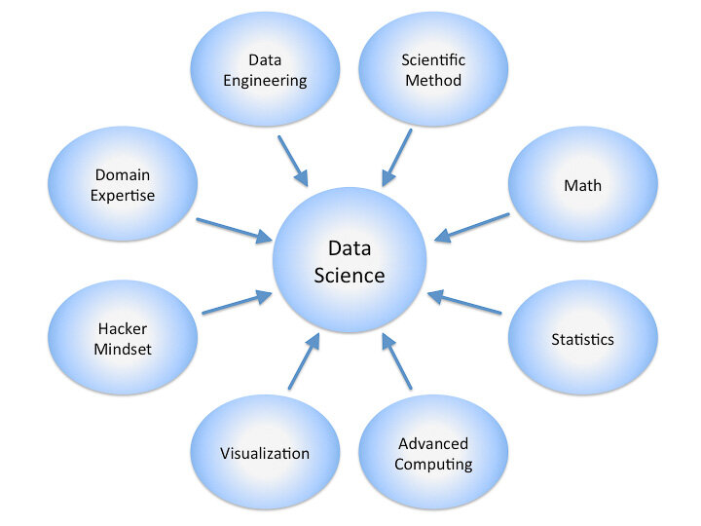

*Fig. Data science*

**5.2 Need of an Data Science**

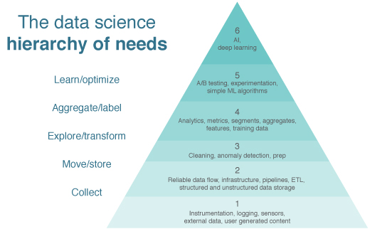

*Fig. Needs of data science*

**5.3 Application of Data Science**

* **Banking:** Banking is one of the biggest applications of Data Science. Big Data and Data Science have enabled banks to keep up with the competition. With Data Science, banks can manage their resources efficiently, furthermore, banks can make smarter decisions through fraud detection, management of customer data, risk modeling, real-time predictive analytics, customer segmentation, etc.
* **Finance:** Data Science has played a key role in automating various financial tasks. Just like how banks have automated risk analytics, finance industries have also used data science for this task. Financial industries need to automate risk analytics in order to carry out strategic decisions for the company. Using machine learning, they identify, monitor and prioritize the risks. These machine learning algorithms enhance cost efficiency and model sustainability through training on the massively available customer data.
* **Manufacturing:** data scientists have acquired a key position in the manufacturing industries. Data Science is being extensively used in manufacturing industries for optimizing production, reducing costs and boosting the profits. Furthermore, with the addition of technologies like the[**Internet of Things (IoT)**](https://data-flair.training/blogs/iot-tutorial/)**,** data science has enabled the companies to predict potential problems, monitor systems and analyze the continuous stream of data.
* **Transport:** Another important application of data science is transport. In the transportation sector, Data Science is actively making its mark in making safer driving environments for the drivers. It is also playing a key role in optimizing vehicle performance and adding greater autonomy to the drivers. Furthermore, in the transport sector, Data Science has actively increased its manifold with the**introduction of self-driving cars.**
* **Healthcare:** In the health-care industry, data science is making great leaps. The various industries in health-care making use of data science are

1. Medical Image Analysis
2. Genetics and Genomics
3. Drug Discovery
4. Predictive Modeling for Diagnosis
5. Health bots or virtual assistants

* **E-commerce:** have been hugely benefitted by data science. Some of the ways in which data science has transformed the e-commerce industries are-

1. For identifying a potential customer base, data science is being heavily utilized.
2. Usage of predictive analytics for forecasting the goods and services.
3. Data Science is also used for identifying styles of popular products and predicting their trends.
4. With data science, companies are optimizing their pricing structures for their consumers.

# **To study Data Analytics its needs & Applications in various domain .**

* 1. **Data Analytics:**

Data analytics is the science of analyzing raw data in order to make conclusions about that information. Many of the techniques and processes of data analytics have been automated into mechanical processes and [algorithms](https://www.investopedia.com/terms/a/algorithm.asp) that work over raw data for human consumption.

Data analytics techniques can reveal trends and metrics that would otherwise be lost in the mass of information. This information can then be used to optimize processes to increase the overall efficiency of a business or system.

Data analytics is a broad term that encompasses many diverse types of data analysis. Any type of information can be subjected to data analytics techniques to get insight that can be used to improve things.

Data analytics can do much more than point out [bottlenecks](https://www.investopedia.com/terms/b/bottleneck.asp) in production. Gaming companies use data analytics to set reward schedules for players that keep the majority of players active in the game. Content companies use many of the same data analytics to keep you clicking, watching, or re-organizing content to get another view or another click.

There are the four types of data Analytics:

1. **Descriptive analytics** describes what has happened over a given period of time. Have the number of views gone up? Are sales stronger this month than last?
2. **Diagnostic analytics** focuses more on why something happened. This involves more diverse data inputs and a bit of hypothesizing. Did the weather affect beer sales? Did that latest marketing campaign impact sales?
3. **Predictive analytics** moves to what is likely going to happen in the near term. What happened to sales the last time we had a hot summer? How many weather models predict a hot summer this year?
4. **Prescriptive analytics** suggests a course of action. If the likelihood of a hot summer is measured as an average of these five weather models is above 58%, we should add an evening shift to the brewery and rent an additional tank to increase output.

[Data mining](https://en.wikipedia.org/wiki/Data_mining) is a particular data analysis technique that focuses on statistical modeling and knowledge discovery for predictive rather than purely descriptive purposes, while [business intelligence](https://en.wikipedia.org/wiki/Business_intelligence) covers data analysis that relies heavily on aggregation, focusing mainly on business information. In statistical applications, data analysis can be divided into [descriptive statistics,](https://en.wikipedia.org/wiki/Descriptive_statistics) [exploratory data analysis](https://en.wikipedia.org/wiki/Exploratory_data_analysis) (EDA), and [confirmatory data analysis](https://en.wikipedia.org/wiki/Statistical_hypothesis_testing) (CDA). EDA focuses on discovering new features in the data while CDA focuses on confirming or falsifying existing [hypotheses.](https://en.wikipedia.org/wiki/Hypotheses) [Predictive](https://en.wikipedia.org/wiki/Predictive_analytics) [analytics](https://en.wikipedia.org/wiki/Predictive_analytics) focuses on application of statistical models for predictive forecasting or classification, while [text analytics](https://en.wikipedia.org/wiki/Text_analytics) applies statistical, linguistic, and structural techniques to extract and classify information from textual sources, a species of [unstructured data](https://en.wikipedia.org/wiki/Unstructured_data). All of the above are varieties of data analysis.

* 1. **Need of an Data Analytics**

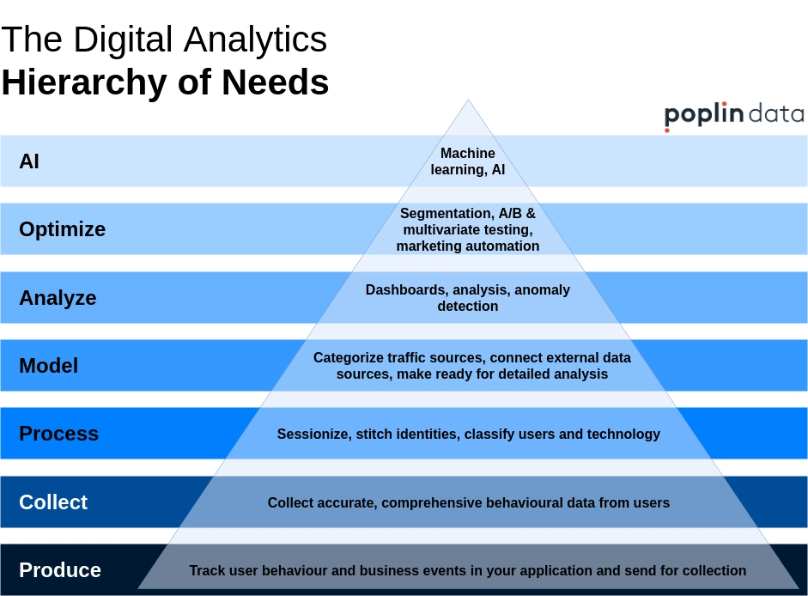

*Fig. Need of an data analytics*

* 1. **Application of an Data Analytics**
* **Finance:** BA is of utmost importance to the finance sector. Data Scientists are in high demand in investment banking, portfolio management, financial planning, budgeting, forecasting, etc. For example: Companies these days have a large amount of financial data. Use of intelligent Business Analytics tools can help use this data to determine the products’ prices. Also, on the basis of historical information Business Analysts can study the trends on the performance of a particular stock and advise the client on whether to retain it or sell it.
* **Security:** Data analytics applications or, more specifically, predictive analysis has also helped in dropping crime rates in certain areas. In a few major cities like Los Angeles and Chicago, historical and geographical data has been used to isolate specific areas where crime rates could surge. On that basis, while arrests could not be made on a whim, police patrols could be increased. Thus, using applications of data analytics, crime rates dropped in these areas.
* **Transportation:** Data analytics can be used to revolutionize transportation. It can be used especially in areas where you need to transport a large number of people to a specific area and require seamless transportation. This data analytical technique was applied in the London Olympics a few years ago.
* **Risk Detection:** Risk management is an essential aspect in the world of insurance. While a person is being insured, there is a lot of data analytics that goes on during the process. The risk involved while insuring the person is based on several data like actuarial data and claims data, and the analysis of them helps insurance companies to realize the risk.
* **Delivery:** Several top logistic companies like DHL and FedEx are using data analysis to examine collected data and improve their overall efficiency. Using data analytics applications, the companies were able to find the best shipping routes, delivery time, as well as the most cost-efficient transport means. Using GPS and accumulating data from the GPS gives them a huge advantage in data analytics.
* **Fast internet allocation:** While it might seem that allocating fast internet in every area makes a city ‘Smart’, in reality, it is more important to engage in smart allocation. This smart allocation would mean understanding how bandwidth is being used in specific areas and for the right cause.

**Healthcare:** While medicine has come a long way since ancient times and is ever-improving, it remains a costly affair. Many hospitals are struggling with the cost pressures that modern healthcare has come with, which includes the use of sophisticated machinery, medicines, etc.

# **To study Block chain Technology its needs & Applications in various domain .**

**7.1 Blockchain Technology**

A blockchain, originally block chain, is a growing list of [records](https://en.m.wikipedia.org/wiki/Record_(computer_science)), called blocks, that are linked using [cryptography](https://en.m.wikipedia.org/wiki/Cryptography). Each block contains a [cryptographic hash](https://en.m.wikipedia.org/wiki/Cryptographic_hash_function) of the previous block, a [timestamp](https://en.m.wikipedia.org/wiki/Trusted_timestamping), and transaction data (generally represented as a [Merkle tree](https://en.m.wikipedia.org/wiki/Merkle_tree" \o "Merkle tree)).

By design, a blockchain is resistant to modification of the data. It is "an open, [distributed ledger](https://en.m.wikipedia.org/wiki/Distributed_ledger) that can record transactions between two parties efficiently and in a verifiable and permanent way".For use as a distributed ledger, a blockchain is typically managed by a [peer-to-peer](https://en.m.wikipedia.org/wiki/Peer-to-peer) network collectively adhering to a [protocol](https://en.m.wikipedia.org/wiki/Protocol_(communication)) for inter-node communication and validating new blocks. Once recorded, the data in any given block cannot be altered retroactively without alteration of all subsequent blocks, which requires consensus of the network majority. Although blockchain records are not unalterable, blockchains may be considered [secure by design](https://en.m.wikipedia.org/wiki/Secure_by_design) and exemplify a distributed computing system with high [Byzantine fault tolerance](https://en.m.wikipedia.org/wiki/Byzantine_fault_tolerance). [Decentralized](https://en.m.wikipedia.org/wiki/Decentralized) consensus has therefore been claimed with a blockchain.

Blockchain was invented by a person (or group of people) using the name [Satoshi Nakamoto](https://en.m.wikipedia.org/wiki/Satoshi_Nakamoto) in 2008 to serve as the public transaction [ledger](https://en.m.wikipedia.org/wiki/Ledger) of the [cryptocurrency](https://en.m.wikipedia.org/wiki/Cryptocurrency) [bitcoin](https://en.m.wikipedia.org/wiki/Bitcoin). The identity of Satoshi Nakamoto remains unknown to date. The invention of the blockchain for bitcoin made it the first digital currency to solve the [double-spending](https://en.m.wikipedia.org/wiki/Double-spending) problem without the need of a trusted authority or central [server](https://en.m.wikipedia.org/wiki/Server_(computing)). The bitcoin design has inspired other applications, and blockchains that are readable by the public are widely used by [cryptocurrencies](https://en.m.wikipedia.org/wiki/Cryptocurrencies).

Blockchain, sometimes referred to as Distributed Ledger Technology (DLT), makes the history of any digital asset unalterable and transparent through the use of decentralization and cryptographic hashing.

A simple analogy for understanding blockchain technology is a Google Doc. When we create a document and share it with a group of people, the document is distributed instead of copied or transferred. This creates a decentralized distribution chain that gives everyone access to the document at the same time. No one is locked out awaiting changes from another party, while all modifications to the doc are being recorded in real-time, making changes completely transparent.

* Blockchain consists of three important concepts:
* Block
* Miners
* Nodes

**7.2 Need of an Blockchain Technology**

Blockchain brings trust, accountability, and transparency to digital transactions. All transactions that exist on a blockchain are shared and distributed among a network of peer-to- peer computers. Transactions are encrypted before they are stored and shared.

Blockchain is a better, safer way to record activity and keep data fresh, while maintaining a record of its history. The data can't be corrupted by anyone or accidentally deleted, and you benefit from both a historical trail of data, plus an instantly up-to-date record.

**7.3 Application of an Blockchain Technology**

1. **Data sharing:**

Cryptocurrency IOTA launched a beta version of its Data Marketplace in November, demonstrating that blockchain could be used as a marketplace to share or sell unused data. Since most enterprise data goes unused, blockchain could act as an intermediary to store and move this data to improve a host of industries. While still in its early stages, IOTA has more than 35 brand-name participants (with Microsoft being one) offering it feedback.

1. **Digital voting:**

Worried about voter fraud? Well, worry no more with blockchain technology. Blockchain offers the ability to vote digitally, but it's transparent enough that any regulators would be able to see if something were changed on the network. It combines the ease of digital voting with the immutability (i.e., unchanging nature) of blockchain to make your vote truly count.

**3.Tax regulation and compliance**

Have I mentioned how important transparency and immutability are yet? For example, marijuana companies can use blockchain as a means to record their sales and demonstrate to lawmakers that they're abiding by local, state, and/or federal laws. More importantly, these sales act as a clear record for the IRS that they've paid their fair share of taxes to the federal government, assuming they're profitable.

**4.Digital IDs:**

More than 1 billion people worldwide face identity challenges. Microsoft  is looking to change that. It's creating digital IDs within its Authenticator app currently used by millions of people which would give users a way to control their digital identities. This would allow folks in impoverished regions to get access to financial services, or start their own business, as an example. Of course, Microsoft's attempts to create a decentralized digital ID are still in the early stages.

**5.Food:**

Yet another intriguing use for blockchain could be in tracing food from its origin to your plate. Since blockchain data is immutable, you'd be able to trace the transport of food products from their origin to the supermarket. What's more, should there be a food-borne illness, blockchain would allow the source of the contaminant to be found considerably quicker than it can be now.

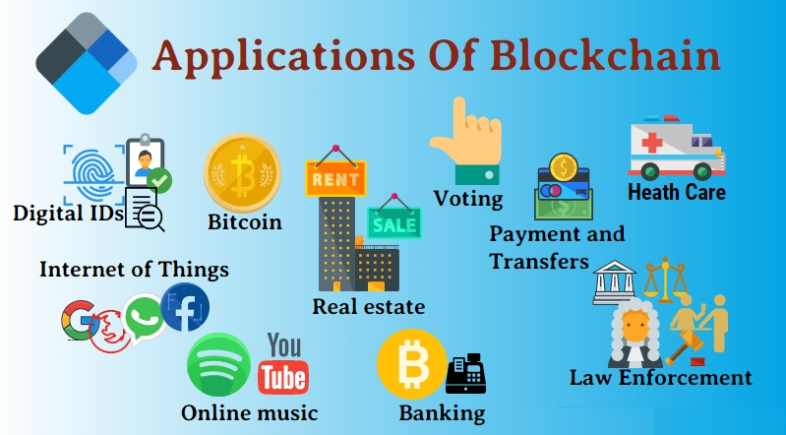

*Fig. Application of Blockchain Technology*

1. **To study of Cyber security its needs & Applications in various domain**

**8.1 Cyber Security**

Cyber security or information technology security are the techniques of protecting computers, networks, programs and data from unauthorized access or attacks that are aimed for exploitation. Major areas covered in cyber security are:

* 1. Application
  2. Information
  3. DisasterRecovery
  4. Network

Application security encompasses measures or counter-measures that are taken during the development life-cycle to protect applications from threats that can come through flaws in the application design, development, deployment, upgrade or maintenance. Some basic techniques used for application security are:

* + 1. Input parameter validation
    2. User/Role Authentication & Authorization
    3. Session management, parameter manipulation & exception management
    4. Auditing

Information security protects information from unauthorized access to avoid identity theft and to protect privacy.

Major techniques used to cover this are:

1. Identification, authentication & authorization of user
2. Cryptography.

Network security includes activities to protect the usability, reliability, integrity and

safety of the network. Effective network security targets a variety of threats and stops them from entering or spreading on the network.

Network security components include:

* 1. Anti-virus and anti-spyware,
  2. Firewall, to block unauthorized access to your network,
  3. Intrusion prevention systems (IPS), to identify fast-spreading threats, such as zero-day or zero-hour attacks
  4. Virtual Private Networks (VPNs), to provide secure remote access.

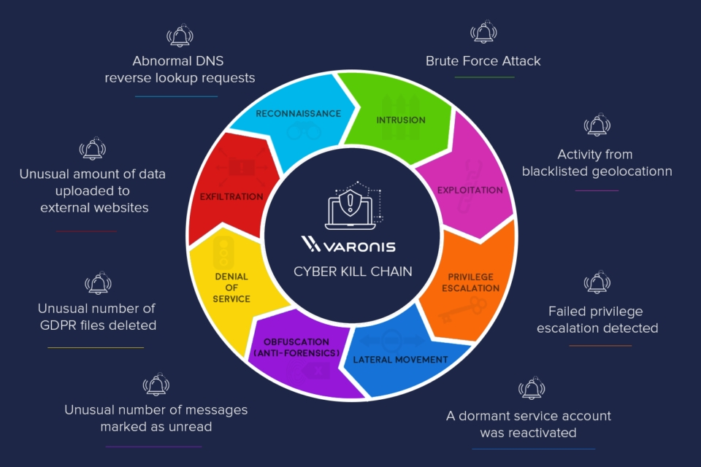

*Fig. Cyber kill chain*

**8.2 Need of an Cyber Security**

Cyber security protects the data and integrity of computing assets belonging to or connecting to an organization's network. Its purpose is to defend those assets against all threat actors throughout the entire life cycle of a cyber attack.

Cybersecurity is important because it encompasses everything that pertains to protecting our sensitive data, personally identifiable information (PII), protected health information (PHI), personal information, intellectual property, data, and governmental and industry information systems from theft and damage attempted

Cyber security demands focus and dedication. Cyber security protects the data and integrity of computing assets belonging to or connecting to an organization's network. Its purpose is to defend those assets against all threat actors throughout the entire life cycle of a cyber attack.

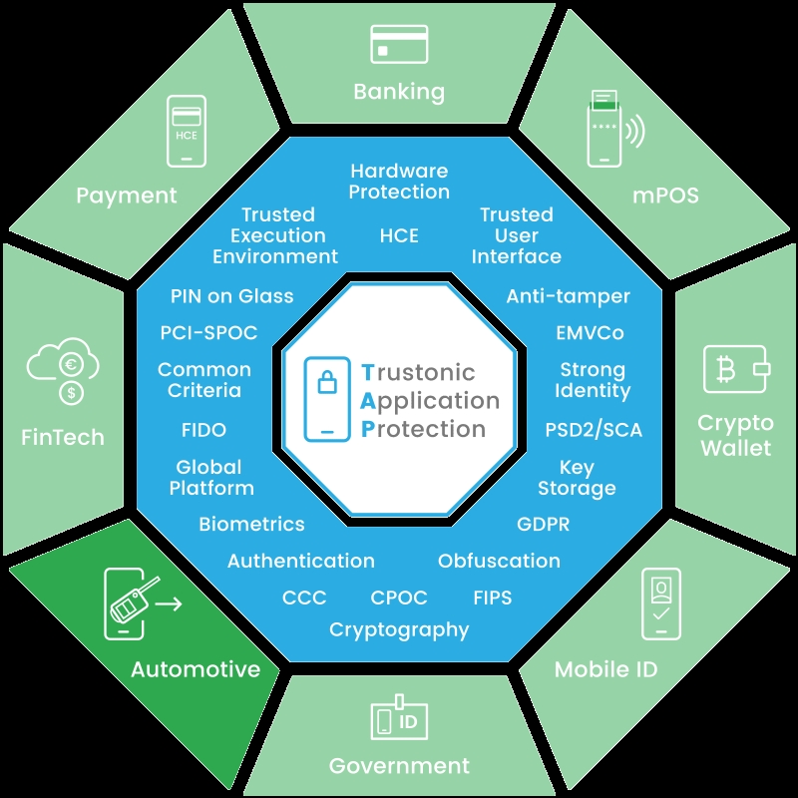**8.3 Application of Cyber S**

*Fig. Application of Cyber Security*

# **To study of Cloud computing its needs & Applications in various domain.**

**9.1 Cloud Computing**

Cloud computing is the on-demand availability of [computer](https://en.wikipedia.org/wiki/Computer) [system resources](https://en.wikipedia.org/wiki/System_resource), especially data storage ([cloud storage](https://en.wikipedia.org/wiki/Cloud_storage)) and [computing power](https://en.wikipedia.org/wiki/Computing_power), without direct active management by the user. The term is generally used to describe [data centers](https://en.wikipedia.org/wiki/Data_center) available to many users over the [Internet](https://en.wikipedia.org/wiki/Internet). Large clouds, predominant today, often have functions distributed over multiple locations from central [servers.](https://en.wikipedia.org/wiki/Server_(computing)) If the connection to the user is relatively close, it may be designated an [edge server](https://en.wikipedia.org/wiki/Edge_server).

Clouds may be limited to a single [organization](https://en.wikipedia.org/wiki/Organization) (enterprise clouds), or be available to many organizations (public cloud).

Cloud computing relies on sharing of resources to achieve coherence and [economies of](https://en.wikipedia.org/wiki/Economies_of_scale) [scale.](https://en.wikipedia.org/wiki/Economies_of_scale)

Advocates of public and hybrid clouds note that cloud computing allows companies to avoid or minimize up-front [IT infrastructure](https://en.wikipedia.org/wiki/IT_infrastructure) costs. Proponents also claim that cloud computing allows [enterprises](https://en.wikipedia.org/wiki/Company) to get their applications up and running faster, with improved manageability and less maintenance, and that it enables IT teams to more rapidly adjust resources to meet fluctuating and unpredictable demand, providing the burst computing capability: high computing power at certain periods of peak demand.

Cloud providers typically use a "pay-as-you-go" model, which can lead to unexpected [operating expenses](https://en.wikipedia.org/wiki/Operating_expense) if [administrators](https://en.wikipedia.org/wiki/Network_administrator) are not familiarized with cloud-pricing models.

**9.2 Need of an Cloud Computing**

Cloud computing facilitates the access of applications and data from any location worldwide and from any device with an internet connection. Cost savings; Cloud computing offers businesses with scalable computing resources hence saving them on the cost of acquiring and maintaining them.

**9.3 Application of an Cloud Computing**

Cloud service providers provide various applications in the field of art, business, data storage and backup services, education, entertainment, management, social networking, etc.

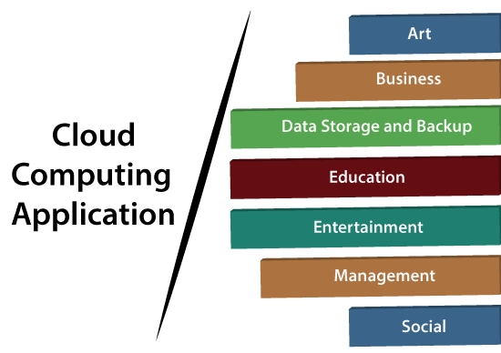

***Fig. Application of Cloud Computing***

1. **To study Industry 4.0 it’s needs and List Minimum 20 IT Product based & Service based Industry.**

**10.1 Industry 4.0**

Industry 4.0 is used interchangeably with the fourth industrial revolution and represents a new stage in the organization and control of the industrial value chain.

Cyber-physical systems form the basis of Industry 4.0 (e.g., ‘smart machines’)*.* They use modern control systems, have embedded software systems and dispose of an Internet address to connect and be addressed via [IoT](https://www.i-scoop.eu/internet-of-things-guide/) (the Internet of Things)*.* This way, products and means of production get networked and can ‘communicate’, enabling new ways of production, value creation, and real-time optimization.

**10.2 Need of Industry 4.0**

The reasons why industry 4.0 is important are the benefits. It helps manufacturers with current challenges by becoming more flexible and reacting to changes in the market easier. It can increase the speed of innovation and is very consumer centered, leading to faster design processes.

Small scale industries are important because it helps in increasing employment and economic development of India. It improves the growth of the country by increasing urban and rural growth. ... The industry is a sector in which the production of goods is a segment of the economy.

**10.3 Top 20 Product Based Companies in Bangaluru India**

* + 1. **Adobe**

Adobe Inc. was founded in December 1982 in a garage by John Warnock and Charles Geschke. Name of the company, Adobe comes from Adobe Creek in Los Altos, California, which ran behind Warnock’s house.

* + 1. **Amazon**

Amazon does not need any introduction in today’s World. Jeff Bezos founded Amazon on July 5, 1994, in Bellevue, Washington, USA.

Some of the best products from Amazon are:

Amazon.com is the World’s # 1 e-commerce website; Cloud computing, and AI-based products, including Amazon Alexa, Amazon Fire TV, Amazon Kindle, etc.

* + 1. **Amdocs**

Amdocs is a market leader in Telecom Domain products and services. Morris Kahn founded Amdocs in 1982 in Israel.

Amdocs(then Aurec Information & Directory Systems) developed a billing software program for phone directory companies.

* + 1. **BMC**

Three Shell Oil employees, Scott Boulette, John J. Moores, and Dan Cloer, founded BMC in September 1980 in Houston, Texas, USA. Companies are derived from their surname initials.

* + 1. **CISCO**

Leonard Bosack & Sandy Lerner, two Stanford University computer professional, founded Cisco in December 1984; Their concept was based on a local area network (LAN) being used to connect geographically disparate computers over a multiprotocol router system.

* + 1. **Facebook**

Facebook was founded by Mark Zuckerberg and five other Harvard fellow in

is a social media, advertising, and technology company. Some of the top products are Facebook, Instagram, Messenger, WhatsApp, Watch, Portal, Oculus, Calibra, Giphy, and other products like Messenger, Watch, and Portal.

### **Google**

Ph.D. students from Stanford University, Sergey Brin and Larry Page started Google search engine as one of their research projects in 1996. They came up with a game-changing algorithm called PageRank.The name was a misspelling of the word “googol.” Google’s initial public offering (IPO) happened in 2004. Larry Page, Sergey Brin, and Eric Schmidt decided to work at Google until 2024.

* + 1. **Hewlett-Packard (HP)**

In 1938, Packard and Hewlett, with 538 dollars, started a part-time job in a rented garage. In 1939 they formed a partnership and decided the name of the company Hewlett-Packard. HP incorporated in August 1947 and went public in November 1957. In a critical piece of their circuit, they used a small incandescent light bulb as a resistor, which is temperature-dependent.

### **International Business Machines Corporation (IBM):**

IBM is often considered one of the best companies on the planet. In the 1880s, four technologies developed the blueprint of what International Business Machines (IBM) is today.

### **Intel**

Intel was founded in 1968 Arthur Rock, along with Gordon E. Moore and Robert Noyce. It is a semiconductor chip manufacturing company used in computer microprocessors. They were the suppliers to computer system manufacturing companies like HP, Apple, Dell, Lenovo. Intel means intelligence information.

Some of the best products from Intel are:

SRAM and DRAM, semiconductor chipsets, motherboard chipsets, network interface controllers, integrated circuits, flash memory, graphics chips, embedded processors, and other devices used for communication and computing.

### **Microsoft**

Bill Henry Gates and Paul Allen founded Microsoft in 1975. In the 1980’s it dominated the personal computer operating system space with MS-DOS, and currently Microsoft Windows.

Some of the best products from Microsoft are:

IntruShield, McAfee Change Control, McAfee DAT Reputation, McAfee E-Business Server, McAfee Entercept, McAfee SiteAdvisor, McAfee VirusScan.

**10.4 Service based Companies**

